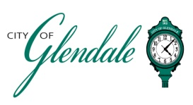
NOTICE OF PUBLIC MEETING
APRIL 30, 2026, 5:00 PM
BOARD OF ALDERMEN SPECIAL MEETING
TENTATIVE AGENDA

- MEETING CALLED TO ORDER
- ROLL CALL
- APPROVAL OF AGENDA
- EXECUTIVE SESSION
- Notice is hereby given that, subject to a motion duly made and adopted, the Board of Aldermen will hold a closed meeting pursuant to (i) RSMo Section 610.021(3) for the purpose of hiring, firing, disciplining or promoting of particular employees when personal information about the employee is discussed or recorded; and (ii) RSMo Section 610.021(13) for the purpose of dealing with matters related to individually identifiable personnel records, performance ratings or records pertaining to employees or applicants for employment.

- ADJOURNMENT

_______________________
Frank Johnson
City Administrator/City Clerk Posted 8:00 A.M. April 29, 2026

